1) Retrieve the customers who have made orders for at least three different products from different categories.

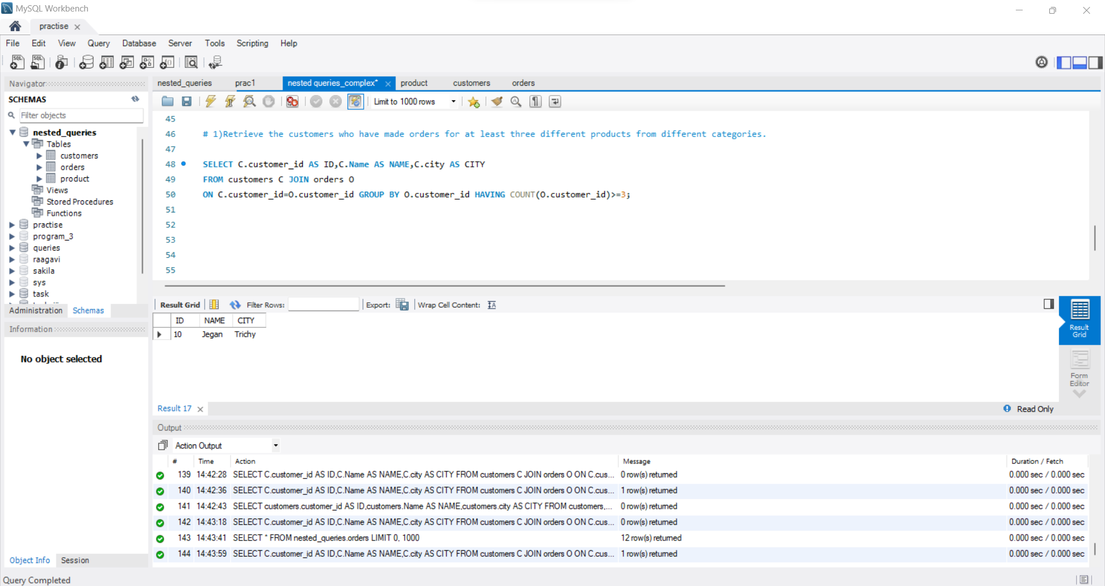

2) Find the products that have been ordered by all customers in a specific city (e.g., CHENNAI").

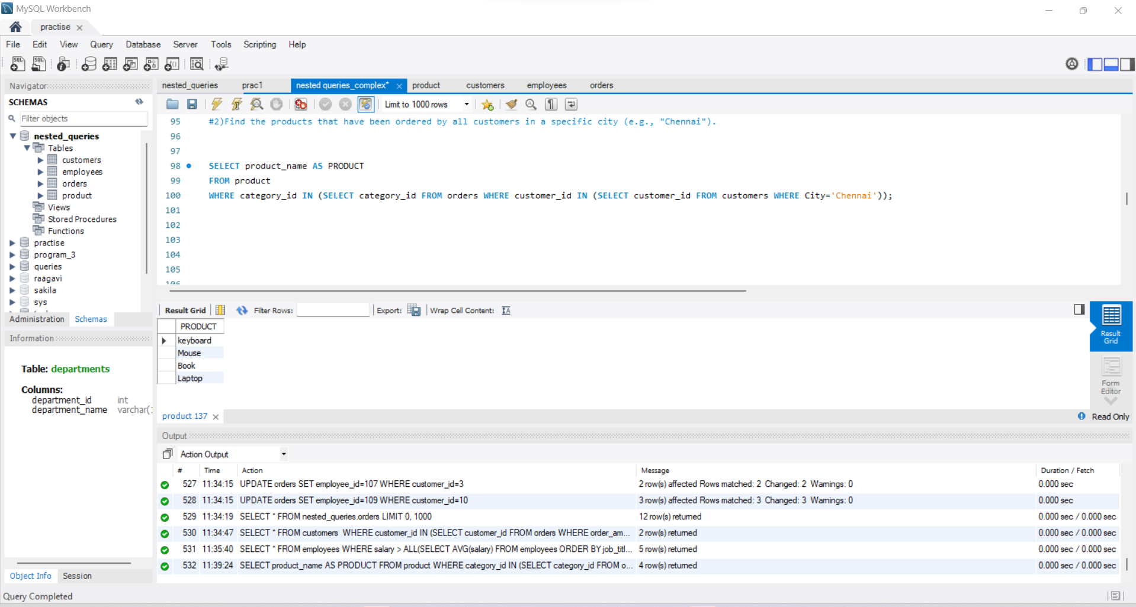

3) List the employees who have a salary higher than the average salary of employees with the same job title in their department.

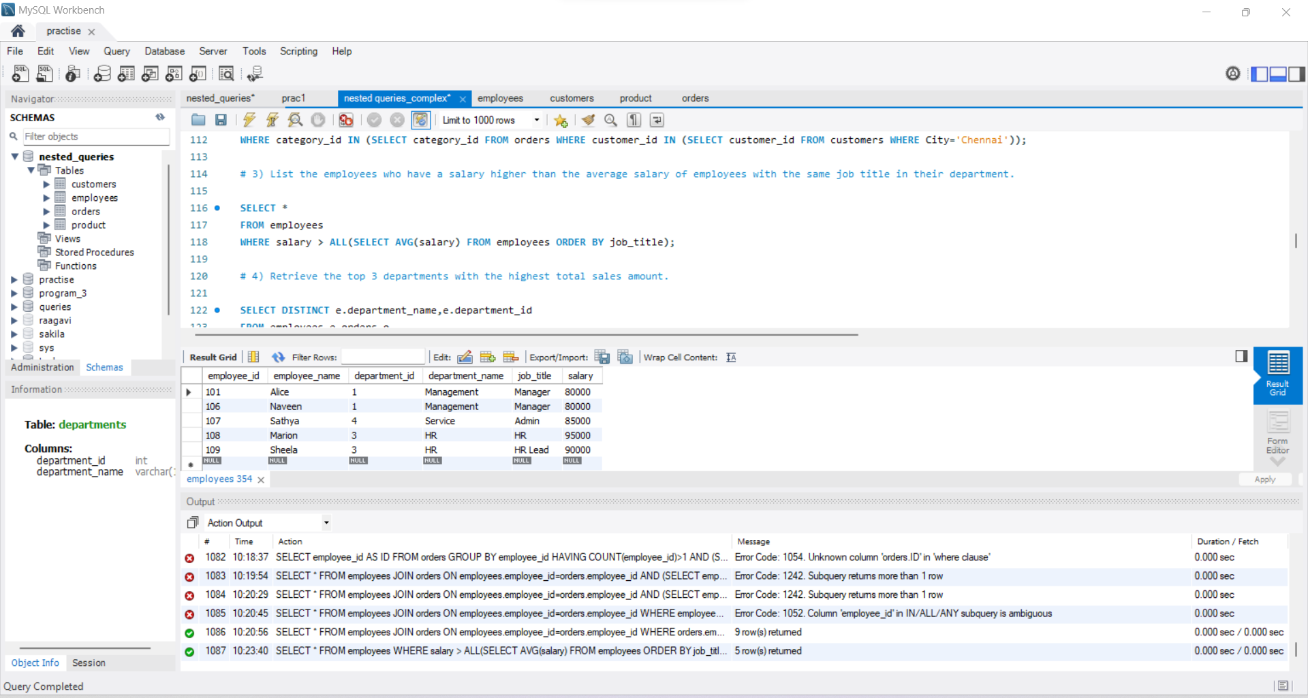

4) Retrieve the top 3 departments with the highest total sales amount.

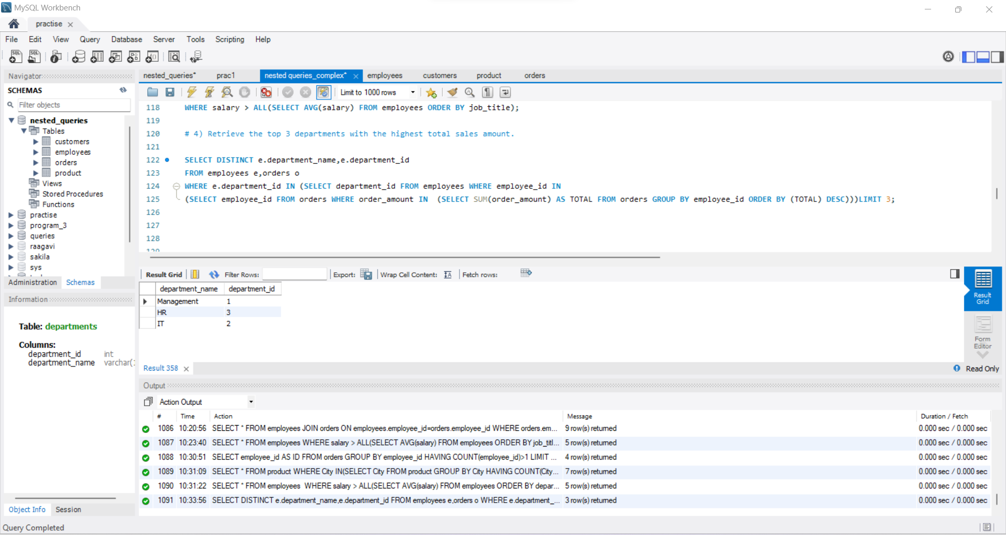

5) Find the customers who have placed orders with a total order amount greater than the average order amount of customers who have placed orders in the last 30 days.

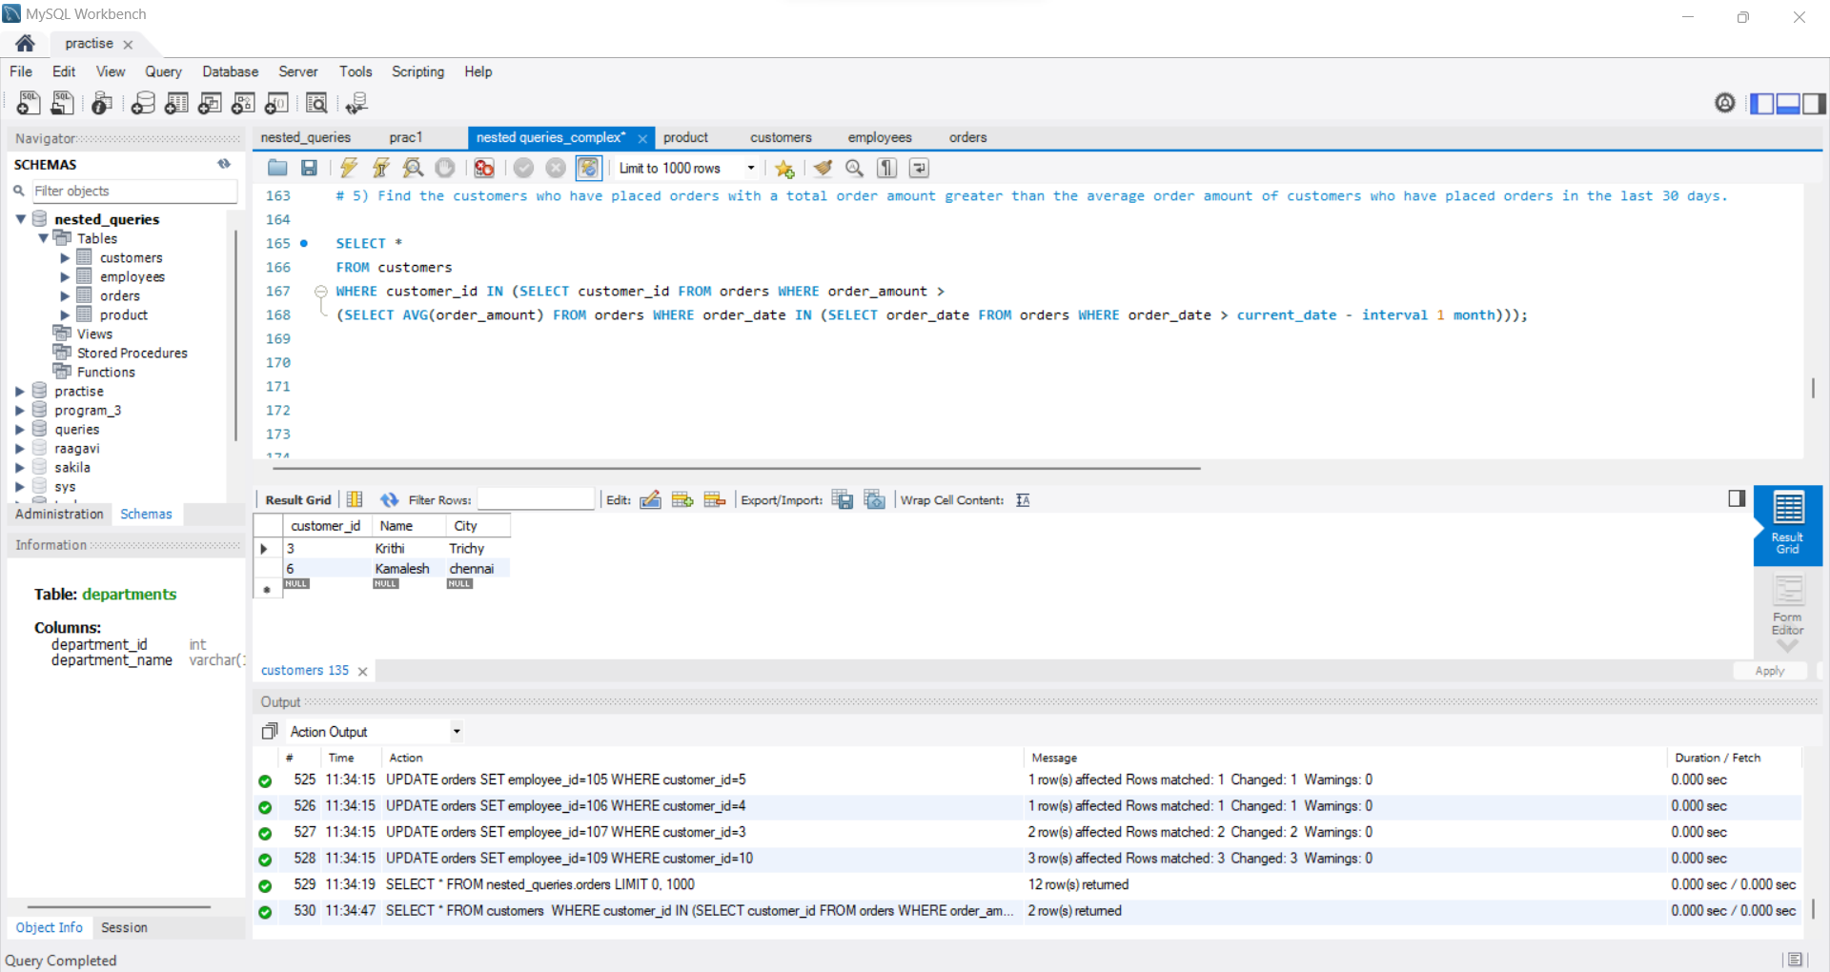

6) Retrieve the names of employees who have made more than one order and have also placed orders on the most recent order date.

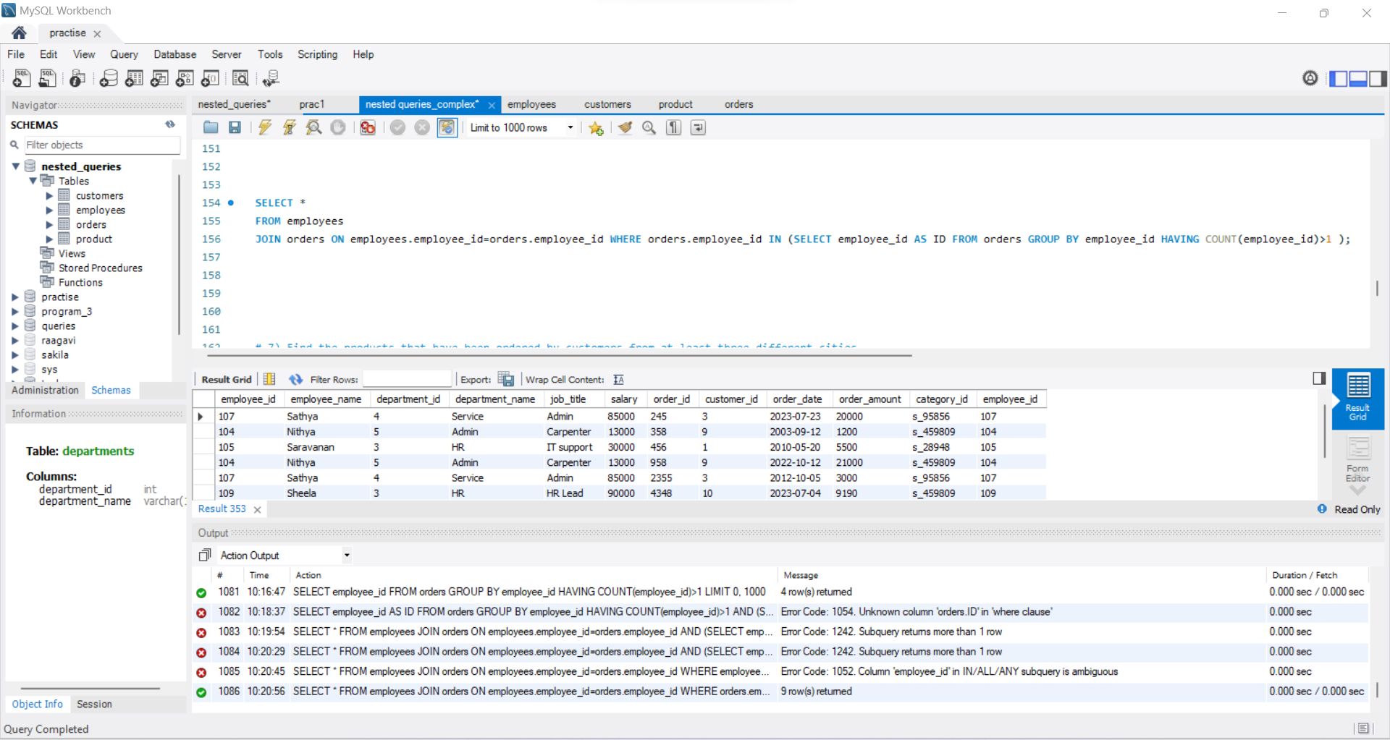

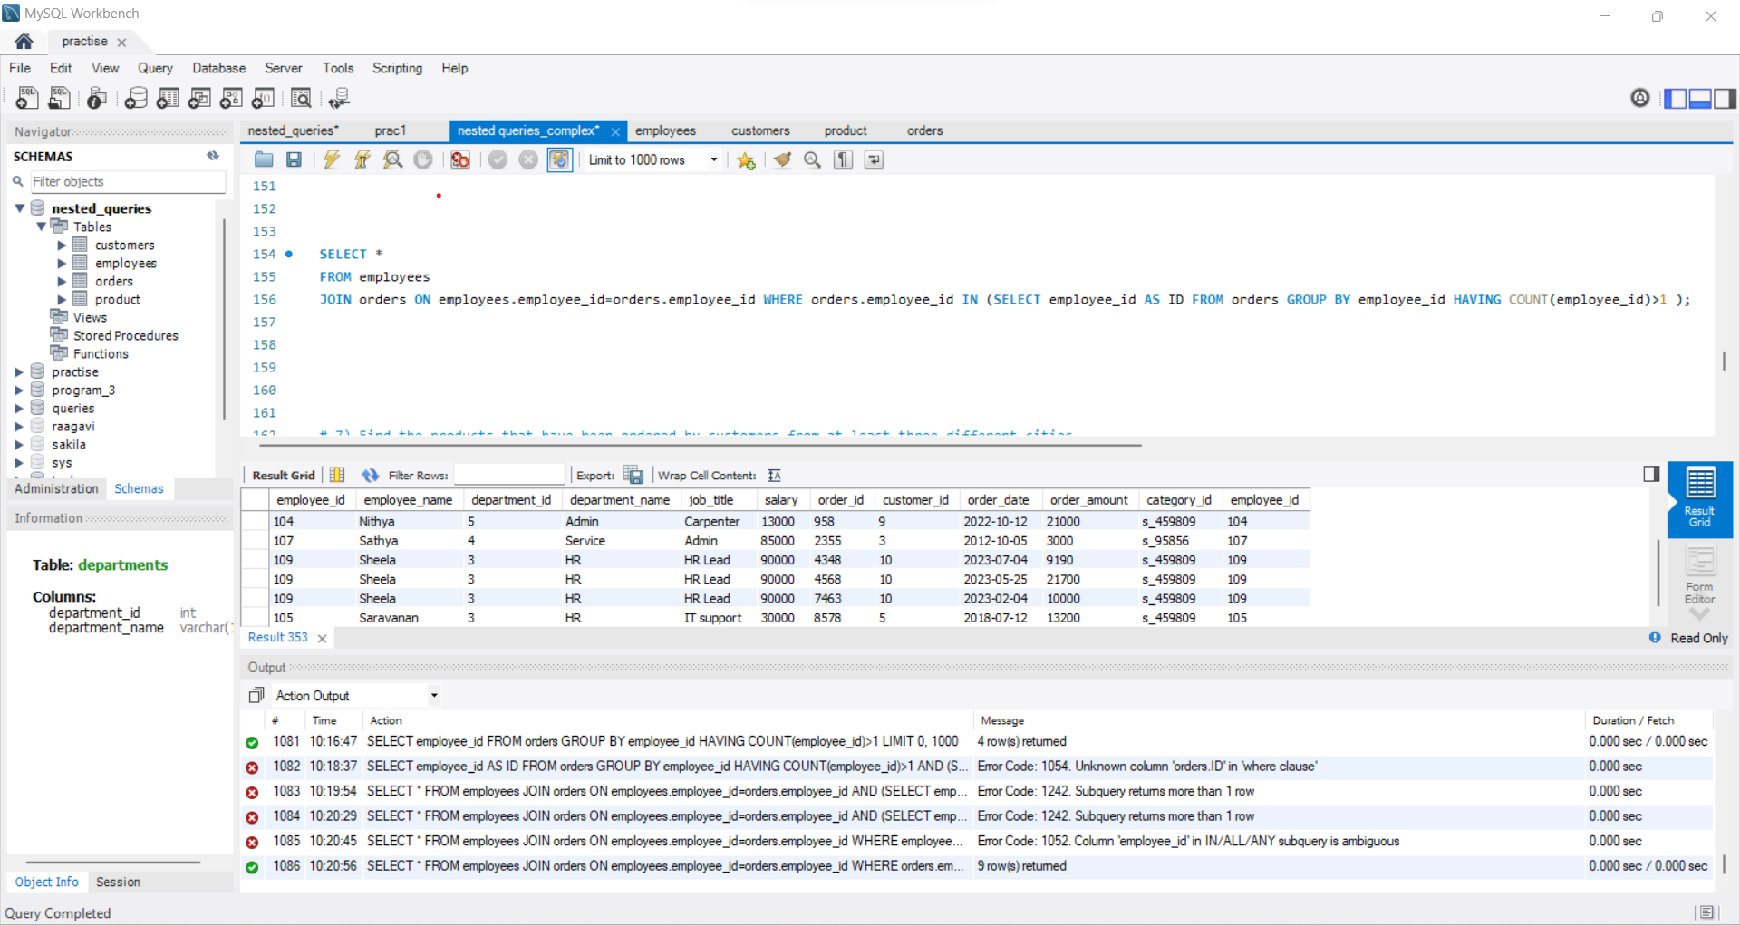

7) Find the products that have been ordered by customers from at least three different cities.

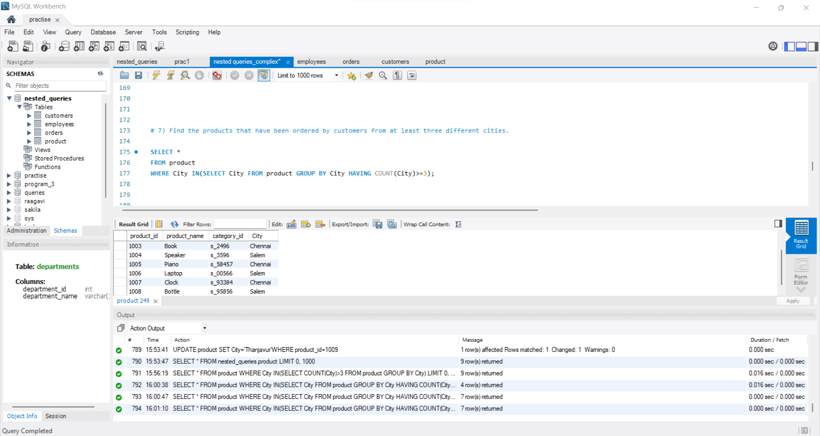

8) List the employees who have a salary higher than the average salary of employees in the same department and have also placed orders.

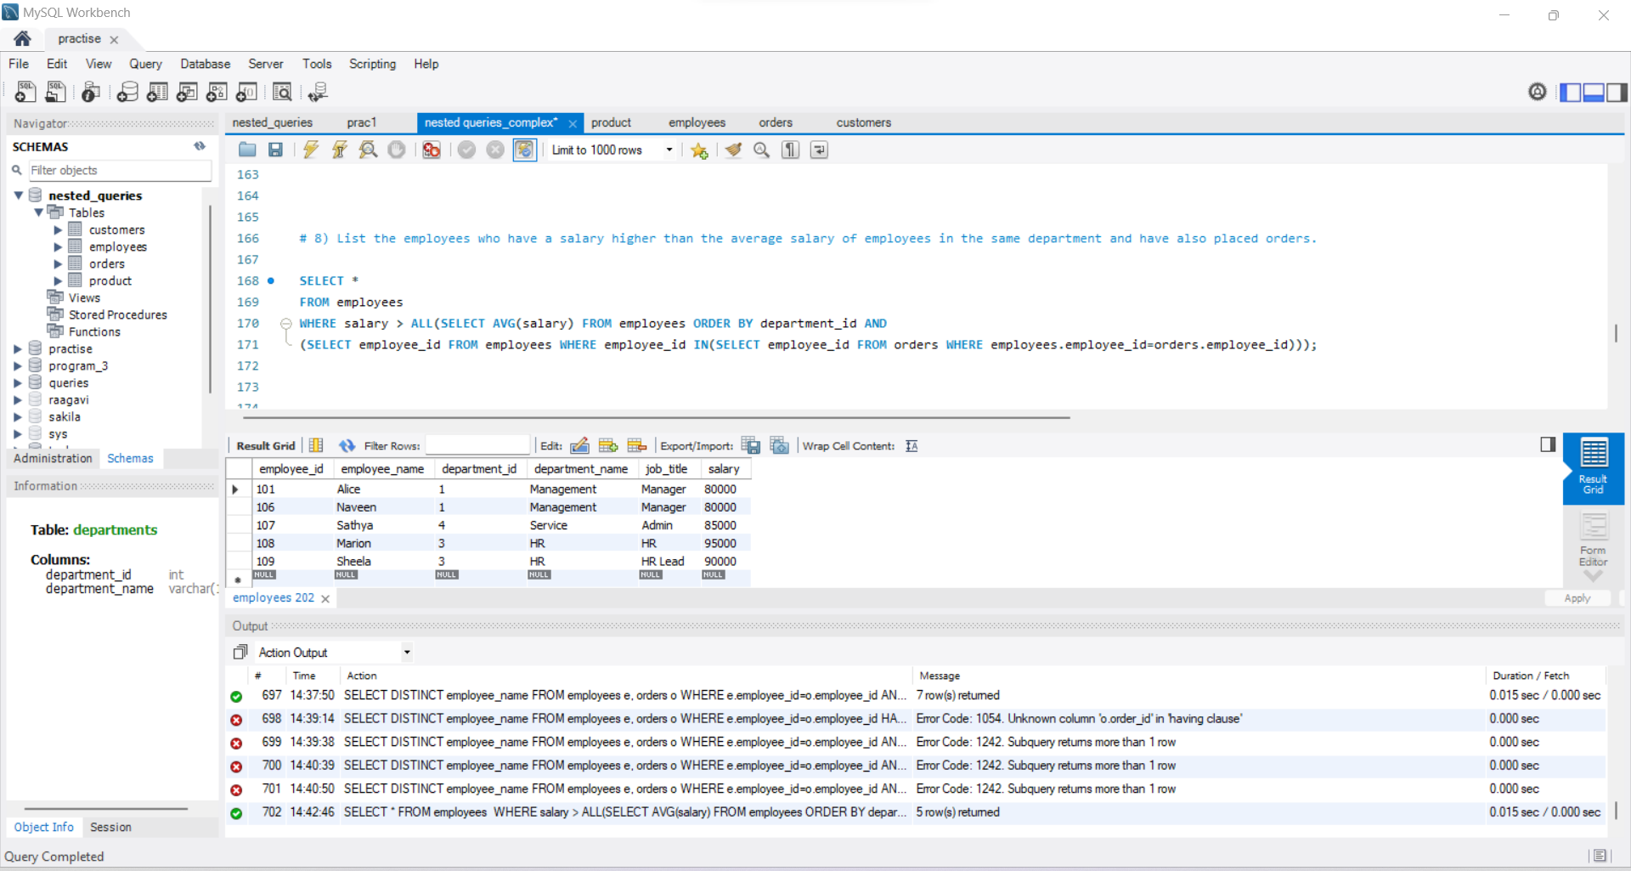

9) Retrieve the customer who has made the highest total purchase amount in each city.

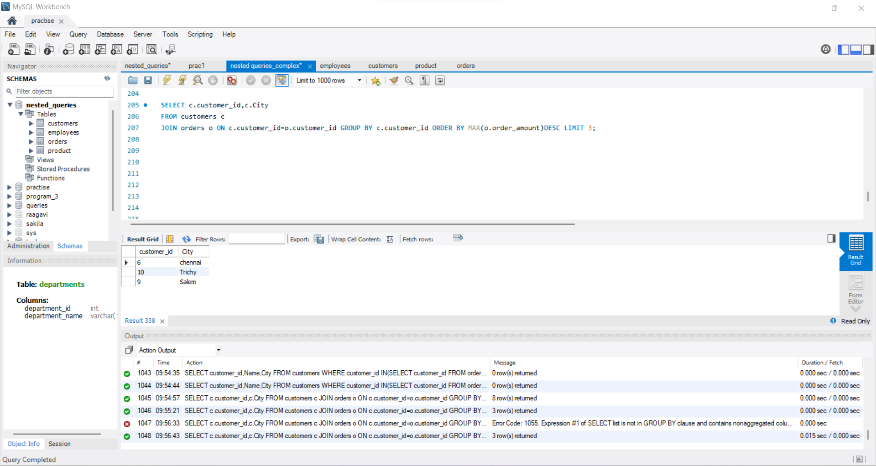

10) Find the customers who have placed orders with a total order amount greater than the average order amount of all orders, excluding the top 5 highest order amounts.

